
How to perform a peer review for a financially conflicted faculty presenter

Thank you for being a peer reviewer.
Reviews must be completed and submitted via CloudCME no later than 3 days prior to the session. This gives the faculty time to make requested edits.
For accreditation purposes, all presentations should be reviewed for evidence-based and unbiased content by a peer reviewer with no conflicts of interest.
- Go to https://uva.cloud-cme.com/default.aspx
- Click on the orange “Faculty” tab
- Click on the “Peer Reviewer Tasks” tab
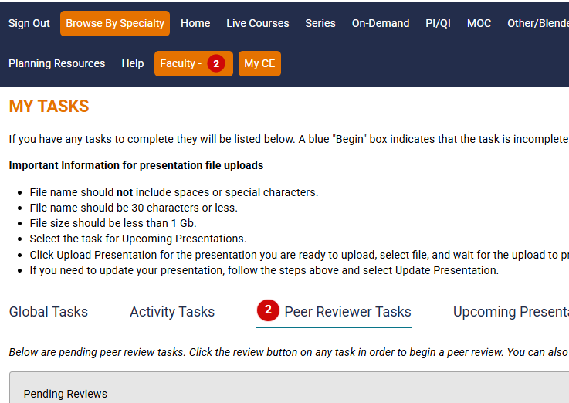
- Faculty tiles include a link to download the materials and the disclosure form.
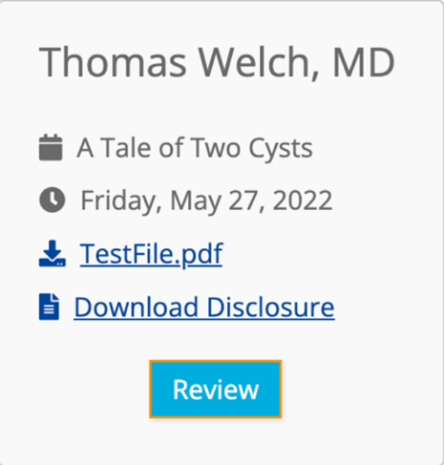
- Click the blue “Review” button to answer questions and complete the form.
  - Financial relationships are listed at the top. You can also view the full pdf of their disclosure form to get more details.
  - Download and review the education materials to ensure there is no bias.
    - Assess whether the content disproportionately highlights products associated with the faculty member's disclosed relationships.
    - Assess whether competing products, procedures, or approaches receive appropriate discussion when clinically relevant.
    - Look for omission of reasonable alternatives that could suggest commercial bias.
    - Watch for repeated emphasis on a specific company's product or technology without scientific justification.
    - Identify use of trade names when generic names would be more appropriate.
    - Evaluate whether images, logos, branding, or product-specific references appear promotional.
  - Make sure that the disclosure slide on the materials lists the same disclosures that they have on the disclosure form. If there is a discrepancy, reach out to UVACE.
- Sign, date, and submit.

